Hill Country MHDD 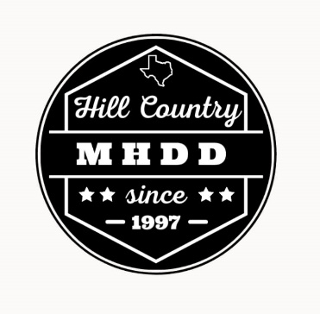
4th Annual Car Show Registration Form

Name_____________________________________________ Phone_________________________
Address___________________________________________________________________________
City________________________________State___________Zip Code____________________
E-mail Address____________________________________________________________________
Entrant’s Car/Vehicle Information:

Year________________Make________________________Model___________________________

Hill Country MHDD Car Show will take place March 21, 2026; rain or shine, unless inclement
weather causes cancellation. There is no rain date, and no refunds will be issued; entry is by donation to
Hill Country MHDD Foundation, a 501(c)(3) charitable non-profit organization.
Gate opens to the registrants at 10:00am and entrant must be parked by 11:15 am to be considered
for judging. Judging starts at 12:00 pm and ends at approximately 2:00pm with the
awards ceremony taking place at 3:00 pm. Entrants shall not remove their vehicle prior to the
conclusion of the awards ceremony without permission from a Hill Country MHDD show official.
I hereby assume full and complete responsibility for any personal injury to myself
or others in my party, or for any loss or damage to my automobile(s), equipment,
and personal property whether by accident, vandalism, or any other
cause which may occur during my participation in this event, and hereby
indemnify, release, and hold harmless from any and all claims the entity known as
the Hill Country MHDD Centers, its directors, officers, and volunteers.
By signing I agree that I have read this document in its entirety.

Entrant Signature: _________________________________________________________________

Date: ________________

