

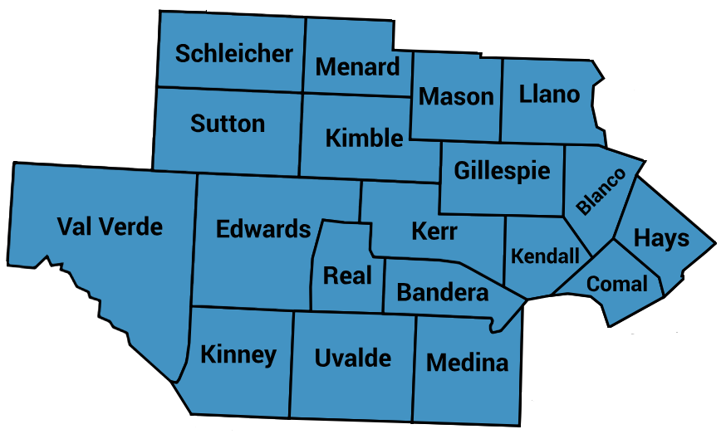

FY 2025-2027 LIDDA

Local Provider Network Development Plan

Contents

Introduction 3
Local IDD Authority Services and Responsibilities 13
Section I.A: Local IDD Authority Services and Responsibilities 13
Section I.B: Community Participation in Planning Activities 16
Section II: Plans and Priorities 18
Section II.A: Cost Effectiveness and Value of Service Delivery Options 18
Section II.B: Least Restrictive Environment 19
Section II.C: Goals to Divert People from the Criminal Justice System 19
Section II.D: Communication Plans 19
Section II.E: Crisis Response Process and Gaps 20
Section III. Resource and Network Development 20
Section IV. System Development and Identification of New Priorities 27
Conclusion to Local Plan Network Development Plan 31
ATTACHMENT A. References 32
ATTACHMENT C. 2024 Needs Assessment 33

Introduction
Beginnings
The Hill Country Mental Health and Developmental Disabilities Center (HCMHDDC) began operation in September of 1997. Prior to that date, components of six different State Facility Community Service divisions were merged to form a State Operated Community Service organization in September of 1996. As part of the initial foundation, staff met to develop the Mission, Values and Workplace Principles as a foundation for the newly formed organization, Hill Country Mental Health, and Developmental Disabilities Centers (HCMHDDC).

The Board of Trustees and Community Advisory Council
The Board of Trustees and Community Advisory Council for HCMHDDC Centers represent population areas of the catchment region that are equal. Some board members represent one county, and others represent multiple counties depending on the population of the counties. The Community Advisory Council has and continues to take an active role in providing community input into the strategic direction of the agency.

Purpose
The Center’s purpose is to help people have positive control over the life they desire and find satisfying and are recognized and valued for their contributions to their communities. Through our adult and child behavioral health, intellectual and developmental disabilities, substance abuse, crisis care, and justice involved services programs, we promote hope, independence, community integration and recovery.

Vision, Mission, and Values

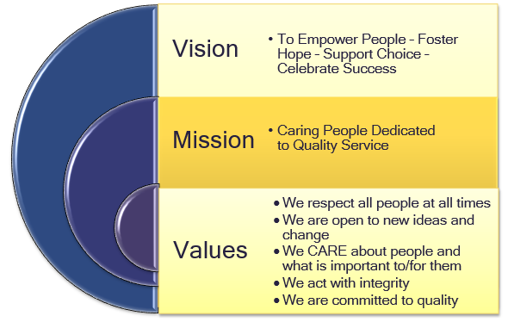

C.A.R.E. Goals
To accomplish our vision, mission, and values it is important to and for us to achieve our C.A.R.E. goals. C.A.R.E. is an acronym for:


Goal 1: Connect to people
To continually explore how we can connect to the people we serve, the people we work with, the people in our communities, and the people that fund us. Our effectiveness impacts the health of our communities, and it is important to and for us to have strong relationships. It is important to build relationships by listening and acting on what we discover.
Goal 2: Align our strategic initiatives
To satisfy the people we are connected to it is important to and for us to align our strategic initiatives or to align our services and business processes to determine what we must excel. Alignment is crucial to ensure that all parts of the organization are working together effectively to achieve our goals. The best indicator for organizational alignment is results. Metrics that define the specific results desired should be established based on goals and objectives. Progress should be monitored, and improvements and corrections made when results are not as expected.
Goal 3: Reliable service and support
To address the concerns of the people we are connected to it is important to and for us to strive to provide the most reliable service and support. We need to ensure timely access and delivery of our service and support.
Goal 4: Enhance the quality of our operations
To achieve our vision, mission, and values it is important to and for us to enhance our culture of improvement. We need to listen as an organization to the people we are connected to and change as the data is provided to improve our operations.

Catchment Area and Population Diversity
Today, HCMHDDC Centers is one of thirty-nine agencies that operate as LIDDA in communities across Texas. The HCMHDDC serves a broad and diverse catchment area in Texas, encompassing 19 counties across the central and western regions of the state: Bandera, Blanco, Comal, Edwards, Gillespie, Hays, Kendall, Kerr, Kimble, Kinney, Llano, Mason, Medina, Menard, Real, Schleicher, Sutton, Uvalde and Val Verde.
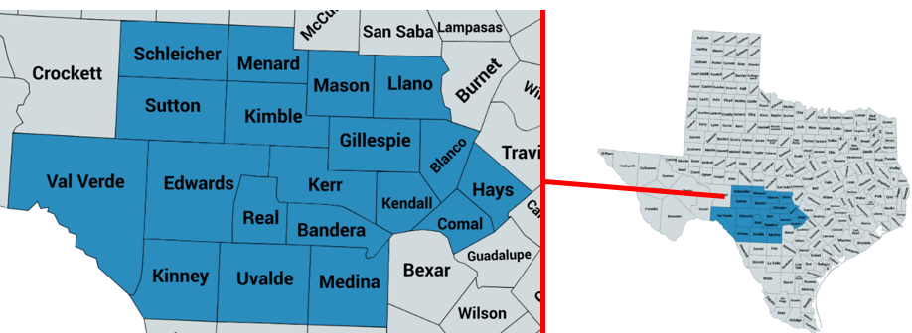

HCMHDDC Centers has 6 Developmental Disability Centers serving a population of over 742,418 in 2022 to an estimated 809,329 people in 2023. This correlates with a 9.01% increase in one year. HXMHDDC operates in over a 22,734 square mile area. This equates to an average population density of 35.69. The population density across the counties varies significantly, ranging from sparsely populated areas like Edwards County, with only 0.87 people per square mile, to more densely populated regions like Hays County, which has 400.43 people per square mile. This variation reflects differing levels of urbanization and land usage in the counties.

This diverse population includes individuals from all walks of life, each facing unique challenges and needs related to mental health and developmental disabilities. The HCMHDDC provides comprehensive, person-centered services across this vast region, ensuring access to care and support for those in need, regardless of their location. HCMHDDC Centers serves a region of Texas that cannot be narrowly defined. There are pockets of the Greater Texas Hill Country Region with high rates of population growth particularly in those counties contiguous to Travis and Bexar counties, such as Hays, Comal, and Kendall counties. Some of the regions are sparsely populated with few, if any, alternative resources for behavioral health and intellectual and developmental disability services. A section of the region is on or close to the border of Mexico where we face the challenge of ensuring a provider network that is culturally diverse. Some counties are considered frontier.

Population Data Summary for 2022 and 2023
This table summarizes population data for HCMHDDC’s catchment area in 2022 and 2023, along with the percentage increase or decrease, land area in square miles, and population density for 2023.

County | Population (2022) | Population (2023) | % Population +/- | Square Miles | Density
Bandera | 20,851 | 22,435 | 7.60% | 798 | 28.11
Blanco | 11,750 | 13,048 | 11.05% | 713 | 18.30
Comal | 171,894 | 185,085 | 7.67% | 575 | 321.89
Edwards | 1,990 | 1,846 | -7.24% | 2,128 | 0.87
Gillespie | 26,988 | 28,268 | 4.74% | 1,062 | 26.62
Hays | 241,067 | 272,289 | 12.95% | 680 | 400.43
Kendall | 47,125 | 54,583 | 15.83% | 663 | 82.33
Kerr | 52,802 | 55,210 | 4.56% | 1,107 | 49.87
Kimble | 4,457 | 4,150 | -6.89% | 1,251 | 3.32
Kinney | 3,595 | 3,469 | -3.50% | 1,365 | 2.54
Llano | 20,682 | 22,953 | 10.98% | 966 | 23.76
Mason | 3,966 | 4,126 | 4.03% | 932 | 4.43
Medina | 50,483 | 57,559 | 14.02% | 1,335 | 43.12
Menard | 2,066 | 2,893 | -1.45% | 902 | 2.26
Real | 3,318 | 3,499 | -11.15% | 700 | 4.21
Schleicher | 2,750 | 24,664 | 5.20% | 1,311 | 2.21
Sutton | 3,995 | 48,268 | -12.42% | 1,454 | 2.41
Uvalde | 24,380 | 22,435 | 1.16% | 1,559 | 15.82
Val Verde | 48,259 | 13,048 | 0.02% | 3,233 | 14.93
Total | 742,418 | 809,329 | 9.01% | 22,734 | 35.60
Sources: U.S. Census Bureau (2022), Texas Almanac

Overview of IDD
Intellectual and Developmental Disabilities (IDD) refer to a group of disorders characterized by significant limitations in both intellectual functioning (such as reasoning, learning, and problem-solving) and adaptive behavior, which includes a range of social and practical skills. These disabilities typically manifest before the age of twenty-two and can result from a variety of genetic, environmental, or other factors. IDD encompasses conditions such as Down syndrome, cerebral palsy, and Fragile X syndrome, and the impact on an individual's daily life can vary widely based on the severity and specific characteristics of the condition. Effective support and intervention, tailored to the individual's needs, are essential for promoting independence, social inclusion, and overall well-being.

This report summarizes the prevalence of Intellectual and Developmental Disabilities (IDD), Mental Health (MH) disorders, and SUD at both the national and state levels, and compares these figures to the estimated prevalence and service coverage in the HCMHDDC catchment area. The assessment aims to provide a clear understanding of how the region's needs align with broader national and state data, helping to identify service gaps and opportunities for improvement.
Overall National Data
- About 1 in 6 children in the U.S. are diagnosed with a developmental disability, and approximately 1.58%% of the general population is estimated to have an intellectual disability.

Overall Texas and HCMHDDC Data
- Texas has a slightly higher prevalence of developmental disabilities than the national average, with an estimated 1.7%, meaning 10,200 people have an intellectual disability in HCMHDD region.
- The following chart represents the estimated number of people who have intellectual disability in HCMHDDC’ counties based on Texas’ prevalence estimates HCMHDD Active Episode (FY 2024)
County | State Prev. IDD | HCMHDDC Served- IDD
Bandera | 300 | 41
Blanco | 174 | 25
Comal | 2,351 | 474
Edwards | 27 | 7
Gillespie | 384 | 87
Hays | 3,947 | 533
Kendall | 713 | 101
Kerr | 741 | 202
Kimble | 58 | 4
Kinney | 51 | 15
Llano | 300 | 67
Mason | 62 | 9
Medina | 737 | 168
Menard | 30 | 6
Real | 46 | 18
Schleicher | 39 | 5
Sutton | 53 | 7
Uvalde | 363 | 155
Val Verde | 300 | 175

LIDDA Staffing Pattern

Department | Function | Position Type | Title | FTE
Access and Intake | Access and Intake | Intake Coordinator | Intake Coordinator | 3
Access and Intake | Access and Intake | Eligibility Authorized Provider | LPA | 2.75
Administration | Director | Regional Director | Regional Director of Service Coordination | 2
Administration | Director | Director | Director of LIDDA Specialized Services | 1
Administration | Administrative | Administrative Specialist | LIDDA Administrative Specialist | 1
Administration | Director | Director | Director of IDD Authority | 1
Administration | Team Lead | Team Lead | Service Coordination Team Lead | 2
Comal LIDDA | Administrative | Office Coordinator | Office Coordinator | 1
Comal SC | Service Coordination | Service Coordinator | Service Coordinator | 5
Hays LIDDA | Administrative | Office Coordinator | Office Coordinator | 1
Hays SC | Service Coordination | Service Coordinator | Service Coordinator | 6
Kerr LIDDA | Administrative | Office Coordinator | Office Coordinator | 1
Kerr SC | Service Coordination | Service Coordinator | Service Coordinator | 6
LIDDA Crisis Intervention | Lead Crisis Intervention Specialist | Lead Crisis Intervention Specialist | Lead Crisis Intervention Specialist | 1
Medina LIDDA | Administrative | Office Coordinator | Office Coordinator | 0.3
Medina SC | Service Coordination | Service Coordinator | Service Coordinator | 2
PASRR Habilitation Coordination | PASRR Habilitation Coordination | Habilitation Coordinator | Habilitation Coordinator | 4
Uvalde LIDDA | Administrative | Office Coordinator | Office Coordinator | 0.7
Uvalde SC | Service Coordination | Service Coordinator | Service Coordinator | 2
Val Verde LIDDA | Administrative | Office Coordinator | Office Coordinator | 1
Val Verde SC | Service Coordination | Service Coordinator | Service Coordinator | 3
Vocational Apprenticeship Program | Vocational Apprenticeship | Apprenticeship Coordinator | Apprenticeship Coordinator | 1
Vocational Apprenticeship Program | Vocational Apprenticeship | Job Coach | Apprenticeship Job Coach | 2

Service Locations
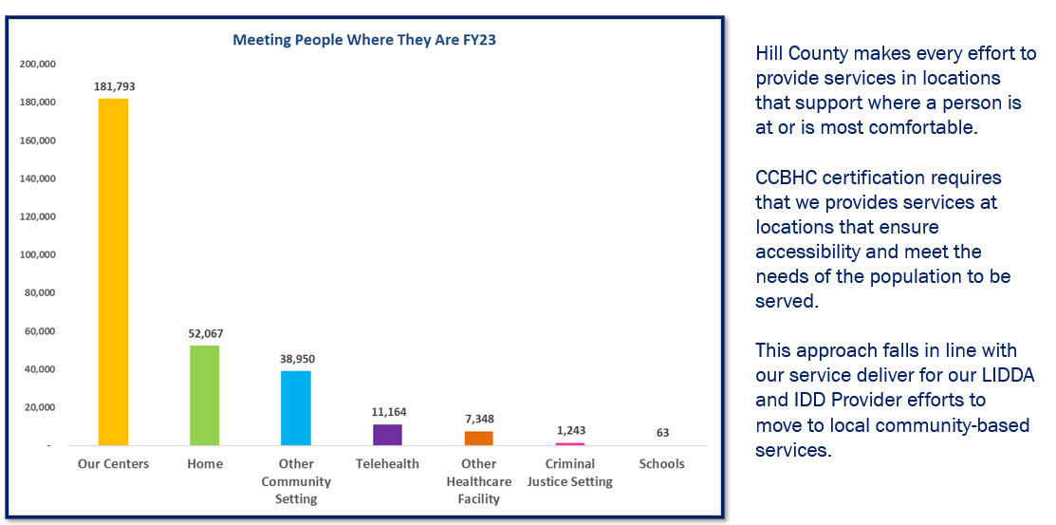

Responsive Services
The overarching challenge facing HCMHDDC Centers is the need to be responsive and open to the needs of the hundreds of communities in the 19-county service region while ensuring an efficient and cost-effective operation with the use of public funding. As the Local Intellectual and Developmental Disability Authority (LIDDA), HCMHDDC remains committed to evaluating the intellectual developmental disability needs of communities by collaborating with community partners and developing innovative programming using available local resources. These commitments are recognized by:

- Ensuring people who need services can exercise individual choice by helping people decide on their services, service provider and location of services.

- Ensuring the best use of public money to create a network of service providers.

- Making recommendations on the most appropriate services available to individuals who need services.

- HCMHDDC Centers will meet this challenge with the support of our diverse staff, the Community Advisory Council, our community providers, stakeholders, and Board of Trustees.

Commitment to Person-Centered and Integrated Care
HCMHDDC operates with a focus on person-centered care, ensuring that everyone’s Person Directed Plans (PDP) are tailored to their unique needs and preferences. This approach fosters a collaborative environment where individuals and their families are empowered to actively participate in their care. Additionally, the organization works to integrate mental health, developmental disability, and substance use services, recognizing the overlap between these areas and striving to provide holistic care.
Impact on the Community
Through our comprehensive service offerings and community partnerships, HCMHDDC has become a lifeline for individuals in rural and frontier communities. The organization plays a critical role in reducing barriers to care, addressing service gaps, and improving health outcomes for some of the most vulnerable populations in the region.
Organizational Chart
The HCMHDDC organization chart provides a clear visual representation of the agency's leadership structure and various departments. It outlines the reporting lines, roles, and responsibilities of key personnel, offering insight into how services for developmental disabilities, and other community support functions are coordinated across the region. This chart helps stakeholders understand the internal organization and the flow of communication within HCMHDDC.
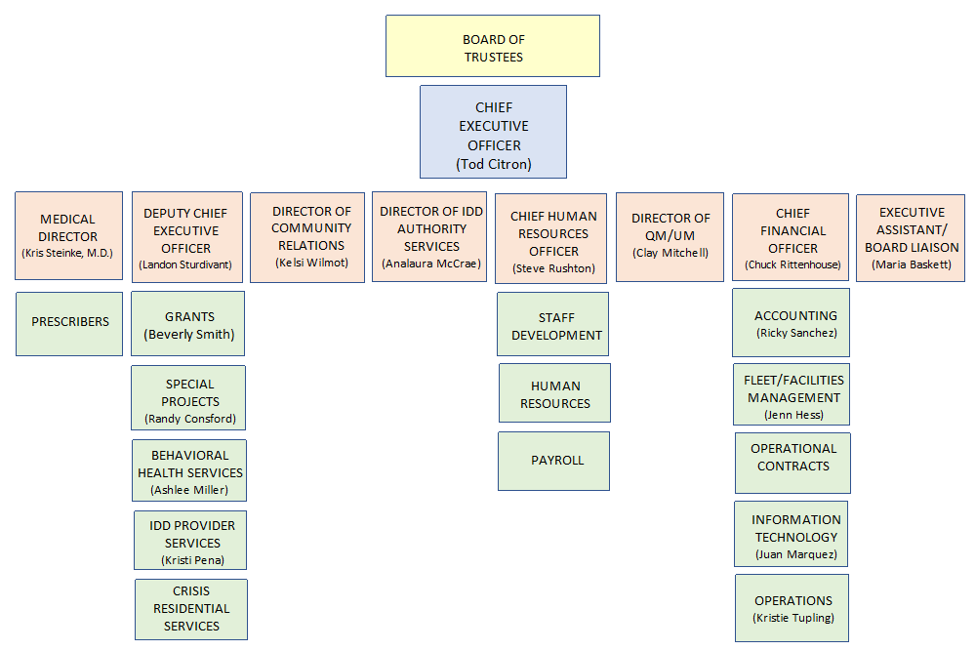

Key findings from the FY 2025 Needs Assessment
The needs assessment for HCMHDDC highlighted several critical areas requiring attention to improve services for individuals with Intellectual and Developmental Disabilities (IDD), Mental Health (MH) conditions, and SUD. The following key findings summarize the most pressing challenges and opportunities identified through data analysis, stakeholder input, and community feedback.
- High Demand for Services Across IDD, MH, and SUD: All 19 counties in the HCMHDDC region report a growing demand for services related to IDD, MH, and SUD. Increases in population, particularly among children and adolescents, are leading to higher rates of diagnosis for autism spectrum disorder (ASD), anxiety, and depression. The co-occurrence of mental health conditions and substance use disorders (dual diagnosis) is common, creating complex needs for service providers.
- Significant Service Gaps in Rural and Frontier Counties: Rural and frontier counties in the HCMHDDC region face significant service gaps due to geographic isolation and workforce shortages. Transportation challenges and long travel distances to providers create barriers for individuals seeking care. Several counties lack local inpatient services, crisis stabilization units, and specialized care programs, leading to over-reliance on emergency departments and out-of-area facilities.
- Workforce Shortages and Turnover: Workforce shortages are a critical issue across all service areas, including behavioral health professionals, direct support professionals (DSPs), and substance use treatment providers. Turnover rates, particularly in rural areas, further strain the system and reduce the continuity of care for individuals. Recruitment and retention efforts are hampered by low wages, burnouts, and limited professional development opportunities.
- Limited Access to Crisis and Inpatient Services: There is a shortage of crisis response teams and inpatient services in the region, particularly for individuals experiencing acute behavioral health or substance use crises. Limited availability of Mobile Crisis Outreach Teams (MCOT) and crisis stabilization units leave many individuals without immediate support. Long waiting times for inpatient beds exacerbate the situation, resulting in individuals being held in emergency departments or jails.
- Barriers to Integrated and Coordinated Care: Individuals with co-occurring conditions (IDD, MH, SUD) often experience fragmented care due to a lack of integration between service providers. Data sharing and communication between healthcare, behavioral health, and social services are limited, making it difficult to deliver holistic, person-centered care. Care coordination services are underfunded, reducing the effectiveness of case management and follow-up care.
- Stigma and Discrimination Remain Significant Barriers: Stigma surrounding mental health, substance use, and developmental disabilities continues to prevent individuals from seeking care. Rural communities face higher levels of stigma, leading to social isolation and delayed treatment. Public awareness campaigns and community education programs are needed to reduce stigma and improve engagement with services.
- Lack of Specialized Services for Vulnerable Populations: Vulnerable populations, including veterans, LGBTQ+ individuals, and people involved with the criminal justice system, face significant barriers to accessing specialized care. There is a lack of tailored programs to meet the specific needs of these populations, particularly in rural areas. Specialized services for children, adolescents, and the elderly are also limited, contributing to unmet needs for these age groups.
- Social Determinants of Health Impact Access to Care: Social determinants of health (SDOH), including poverty, housing instability, and lack of transportation, have a significant impact on access to care. Individuals with IDD, MH, and SUD are disproportionately affected by these social factors, leading to higher rates of hospitalization, homelessness, and unemployment. Addressing social determinants is essential for improving long-term health outcomes in the region.
Conclusion: The key findings from HCMHDDC need assessment highlight the urgent need for expanded services, workforce development, and community engagement. Addressing these challenges will require coordinated efforts from local stakeholders, service providers, and policymakers to ensure that individuals with IDD, MH, and SUD receive the care and support they need. HCMHDDC has been targeting each of these areas, working on expansion and grants that have or are creating new opportunities and services to address these issues. A review of expansion services will be included at the end of this assessment.

Local IDD Authority Services and Responsibilities

Section I.A: Local IDD Authority Services and Responsibilities

Screening
The process of gathering information to determine the need for services.

Eligibility Determination
An interview and assessment or endorsement conducted to determine if an individual has an intellectual and developmental disability or is a member of the intellectual and developmental disabilities priority population for services in accordance with state guidelines.

Consumer Benefits
Assistance with applying for and maintaining maximum state and federal benefits.

Service Coordination

Assistance in accessing medical, social, educational, and other appropriate services and support that will help individuals served achieve a quality of life and community participation acceptable to them. Service coordination is ongoing consumer advocacy that leads to linking, coordinating, and collaborating with other agencies for the delivery of outcome-based services and supports to meet the consumer’s needs. The Service Coordinator engages in a variety of activities that can be categorized into four major service areas: prevention, monitoring, assessments and service planning and coordination. Service Coordination focuses on person-centered thinking and planning, in which the individual (or Legal Guardian if applicable) is the key decision maker requiring the services and supports the individual wishes to reach their desired goals. Service Coordination, also known as Targeted Case Management, is performed for the following areas:
- Continuity of Services – Service Coordination provided to:
  - Individuals residing in a state IDD facility whose movement to the community is being planned or
  - for a person who formerly resided in a state facility and is on community-placement status; or
  - an individual enrolled in the HCS or ICF/MR program to maintain the individual’s placement or to develop another placement for the individual.
- HCS or TxHmL Medicaid Waiver Programs – Service Coordination for individuals enrolled in the HCS or TxHmL Program.
- LIDDA Community Services – Service coordination for individuals receiving General Revenue (GR) funded services.
- Community First Choice – Service coordination provided to an individual enrolled in the CFC program.

Preadmission Screening and Resident Review (PASRR)
- PASRR Evaluations - an evaluation of an individual in a nursing facility to determine if the individual is appropriately placed and whether they have a mental health or intellectual and developmental disability that would benefit from alternative placement or supplemental services.
- Habilitation Coordination – coordination provided to an individual identified as having an intellectual or developmental disability who has been admitted to a Nursing Facility.
- LIDDA PASRR Specialized Services – services available to an individual identified as having an intellectual or developmental disability who has been admitted to a Nursing Facility. The LIDDA is responsible for initiation and monitoring provision of these services. These services include:
  - Day Habilitation
  - Independent Living Skills Training
  - Behavioral Supports
  - Employment Assistance
  - Supported Employment

Community Living Options
A process that focuses on providing information on community services and residential options to individuals living in the institutions, such as the State Supported Living Center and Nursing Facilities.

Permanency Planning
A philosophy and planning process that focuses on achieving family support for individuals under 22 years of age by facilitating permanent living arrangements that include an enduring and nurturing parental relationship.

Program Enrollment
- Intermediate Care Facilities for persons with Individuals with Intellectual Disabilities (ICF/IID) – eight to six-bed permanent living environments for persons who qualify for placement.
- Nursing Facilities – provide institutional care to Medicaid recipients whose medical condition regularly requires the skills of licensed nurses. The nursing facility must provide for the total medical, social, and psychological needs of each client, including room and board, social services, over-the-counter drugs, medical supplies and equipment, and personal needs items.
- Texas Home Living Waiver – provides selected essential services and supports to persons with intellectual and developmental disabilities that are living in family homes or their own homes.
- Home and Community-based Services (HCS) – provides individualized services and supports to persons with intellectual and developmental disabilities who are living with their family, in their own home or in other community settings, such as small group homes.

Crisis Intervention
Supports provided by Crisis Intervention Specialists, designed to provide information, and collaborate with a variety of entities, including Service Coordination, Service Planning Teams, MCOT and local law enforcement agencies to prevent and manage crises.

Crisis Respite
Short-term respite providing therapeutic support both in-home and out-of-home settings to prevent and manage crises.

Local IDD Community Services (LCS)
Authorization, coordination, and oversight of the provision of General Revenue-funded community services, including:
- Service Coordination
- Day Habilitation
- Community Supports
- Behavioral Supports
- Nursing
- Respite

Section I.B: Community Participation in Planning Activities

The Local IDD Authority (LIDDA) seeks to be actively responsive to input received from a variety of community stakeholder groups, including the Planning Network Advisory Committee (PNAC), local CRCGs, school districts, advocacy groups, ADRCs, Southwest Texas Regional Advisory Council (STRAC), provider agencies, and other members of the community. In addition, LIDDA participated in the CLSP FY 2025 Needs Assessment.

HCMHDDC conducts a bi-annual needs assessment to evaluate the specific needs of individuals with IDD in our service area. This assessment includes:
- Data Collection: Gathering information from community stakeholders, individuals with IDD, their families, and service providers. Community Surveys, Other
- Assessments, and Community Workgroups: Surveys were distributed to community members in all nineteen counties to capture local perspectives on mental health, substance use, and developmental disability services (See ATTACHMENT A). These surveys gathered information on barriers to care, satisfaction with current services, and suggestions for improvement.
- Identification of Gaps: Assessing current services and identifying gaps in areas such as social determinants of health, housing, employment, behavioral health supports, and crisis intervention.
- Resource Mapping: Evaluating existing resources and supports to determine areas of resource allocation and potential partnerships.

In addition, there are numerous community work groups in each area. The following is a list of workgroups utilized for community connections and input.
Group Name | Description | Meeting Place(s) | Meeting Frequency
Citizens' Advisory Committee (CAC) or Planning and Network Advisory Committee (PNAC) | Local Planning Network Advisory Committee. Members are people that receive services, family members, or community members. | Kerrville, San Marcos, New Braunfels | Quarterly
Blanco County - Community Resource Center Advisory Board | Identify potential agencies to join CRC, identify needs for CRC and advertisement to meet needs of community members | Alternate between church and will be meeting in CRC once open (in Blanco County) | Monthly
Blanco County - Community Resource Center Interagency | Identify needs and gaps in services for Blanco County and know resources to connect people with | Community Resource Center | Monthly
Comal County - CARE (Community Assistance and Resources for Everyone) | A community networking group for local resources and non-profit organizations | Canyon Lake CRRC | Quarterly
Comal County - Churches and Agencies | Designed to strengthen collaboration between faith communities and service providers | Saint Peter and Paul Catholic Church | Monthly
Comal County - CRCG | Community Resource Coordination Group serving children and families in Comal County | NBISD Administration | Monthly
Comal County - Healthcare Steering Committee | Discuss emergency healthcare response in our county | Public Health Building | Monthly
Comal County - Homeless Coalition | Problem solve unmet needs of homeless population in our county | McKenna | Monthly
Comal County - Jail Committee | Identify action steps for inmates with MH/IDD needs, to include discharge planning | Comal County Jail | Monthly
Comal -Comal County Community Coalition Partnership | SACADA to address drug addiction in Comal County |  | Monthly
Gillespie County - Health Board |  |  | Monthly
Gillespie County - School Health Advisory Council |  |  | Quarterly
Gillespie - School Health Advisory Council | Advisory Council to educate and manage the health and welfare of FISD students | Fredericksburg HS | Every 2 months
Hays County - CRCG | Community resource coordination group | Greater San Marcos Youth Council | As needed
Hays County - Interagency | Social services networking | Center for Health Improvement | Quarterly
Hays County - Mental Health Stakeholders Meeting | Discuss process issues surrounding crisis and commitments | Wellbridge | Quarterly
Hays County - Safety Committee | For Dripping Springs school district | Dripping Springs ISD | Quarterly
Kendall County - Hope for the Homeless | Created to address the needs of Kendall County's homeless population | Boerne Library | Monthly
Kerr County - CRCG | Group of local partners and community members that collaborate with parents, caregivers, youth, and adults to make service plans | BCFS Hill Country Resource Center | Monthly
Kerr County - Institute for Healthcare Improvement, Open School Chapter | Community collaboration on how we can help each other and the community, discussion of potential grant ideas | Schreiner University | Monthly
Kerr County - Interagency Meeting | Marketing and sharing information and resources in the community | Light on the Hill | Monthly
Kimble County - Child Protective Services | Discuss individuals in CPS custody and Hill Country services | Kimble County Mental Health | Quarterly
Llano County - CRCG/Mental Health Coalition | Staffing needs of community members | Various | Quarterly
Medina County - Coffee with Cops | Open community discussions | Hondo Library | Monthly
Medina County - CRCG | Discuss overall wellness with all agencies involved | Kerrville | Quarterly
Medina County - Public Health Emergency Preparedness | To discuss the process of disaster and how it relates to all agencies involved | South Texas Regional Medical Center | Annually
Real County - Team Real | Allows groups/individuals to get access and support from community partners in Real County
Uvalde County - CRCG | Group of local partners and community members that collaborate with parents, caregivers, youth, and adults to make service plans to help people with special needs get benefits and services |  | Monthly
Uvalde County - Team Uvalde | Allows groups/individuals to get access and support from community partners in Uvalde County |  | Monthly
Val Verde County - CRCG | Aid individuals in need | BCFS | Monthly
National/State - National Council | Tic Toc 3.0 Infusing Trauma Informed Care throughout Texas | Conference Calls and In-person conferences | Twice a month

Section II: Plans and Priorities

Section II.A: Cost Effectiveness and Value of Service Delivery Options
LIDDA seeks to improve service delivery by establishing processes and methods to ensure individual choice regarding providers of LIDDA Community Services and PASRR Specialized Services. Creation of a provider network would create a competitive market resulting in increased cost efficiency and overall value.

Administrative Efficiencies
- Using bullet format, describe the strategies the LMHA or LBHA is using to minimize overhead and administrative costs and achieve purchasing and other administrative efficiencies, as required by the state legislature (see Appendix C).
- Apply the requirements of Uniform Grant Management Standards when making financial decisions.
- Use internal controls for expenditures which require a chain of approval based on monetary amounts before payment can be processed.
- Implemented state-of-the-art accounting and purchasing systems which have reduced both overhead and administrative costs.
- Contracted with outside companies to audit expenses for telephone, cell phone, internet, and utilities to reduce cost and be remunerated for services that were overcharged.
- Implemented the Paycom system that provides Human Resources efficiencies.
- Implemented Relias Training Program that provides training modules and tracking that has created a more efficient training program.
- Purchased and implemented Netsmart Electronic Medical Records.

Section II.B: Least Restrictive Environment
Through the Discovery Process, which is founded on person-centered philosophies, the LIDDA supports individuals diagnosed with IDD to determine their preferred living environment. This process includes consideration of the support needed to ensure a person remains healthy and safe.

Section II.C: Goals to Divert People from the Criminal Justice System
Through relationships established by Crisis Intervention Specialist with local law enforcement entities, and through ongoing education provided to law enforcement entities, efforts are continually made to increase collaboration and understanding of the IDD population. As relationships strengthen, LIDDA has observed an improvement in knowledge regarding the role of LIDDA and alternatives to criminal justice responses.

Section II.D: Communication Plans
Hill Country recognizes the need for open dialogue and communication with a variety of community partners to ensure that there is adequate and accurate information available on topics such as long-term services and support, eligibility processes, and accessing service systems. LIDDA plans to establish a clear, accurate message in publications and electronic media to be made available to entities such as school districts, resource groups, advocacy groups and others.

Section II.E: Crisis Response Process and Gaps
Through the LIDDA Performance Contract, Hill Country is responsible for providing Crisis Intervention functions as well as ensuring provision of crisis respite. Consistent availability of crisis respite has been identified as a significant barrier. Contributing factors include the unpredictability of demand, variations of age and gender that limit access to certain crisis respite settings, and a dependence bed availability through external contracts. Additionally, limited state funding for comprehensive services place further demands on the Local IDD Authority to respond to crises and provide safety net supports to more individuals.

Section III. Resource and Network Development

Summary of Contracted LIDDA Provider Network
An established network of contracted Local Intellectual and Developmental Disability Authority (LIDDA) providers has been developed to enhance access to services across multiple regions. This network is designed to provide a comprehensive range of supports, ensuring that individuals with intellectual and developmental disabilities receive the care they need within their communities.
The contracted LIDDA providers offer various services, including case management, direct support, behavioral health services, crisis intervention, and host home care, etc. These providers are strategically selected to meet the unique needs of individuals served, ensuring quality and continuity of care across distinct locations.
Provider Organizations
Provider Organization | Service(s)
Cerner Corporation | Administration
Gallagher Benefit Services | Administration
Texas Behavioral Management | Behavioral Health
Athelas, Inc. | Computer Software
Community Brands | Computer Software
FasPsych, LLC | Contract Health Care Professionals
Xerox Business Solutions SW | Copiers
River City Advocacy | Client Operated Center
Avail Solutions | Crisis Hotline
Advantage Care Services | Day Habilitation
Buda Brightside | Day Habilitation
Prestige Staffing | Employment Service
Austin Major Group | Employment Services
Koetter Fire Equipment | Fire Safety & Equipment
Curalinc Healthcare | Healthcare
Kimble Hospital | Hospital
Medina Community Hospital | Hospital
Scott & White Hospital-Dallas | Hospital
Camino Real Community Services | Interlocal Agreement
Communication by Hand | Interpreting Services
San Marcos Interpreting Services | Interpreting Services
Victor A. Gallegos | Janitorial
Clinical Pathology Labs | Laboratory
Quest Diagnostics | Labs
Ainsa, Hutson, Hester & Crews | Law Firm
Taylor, Olson, Adkins, Sralla | Law Firm
Domingo Gonzalez | Lawn Maintenance
Clarissa Araujo | Maintenance
German Saldivar | Maintenance
Jani-King of SA | Maintenance
Texas A&M Corpus Christi | Nursing
Texas Vista Medical Center | Nursing
UTHSC – SA | Nursing
Genoa | Outsourced Pharmacy Services
IPM | Pharmacy Benefit Management
University of Texas Health Science Center San Antonio Psychiatry Residency | Contract Healthcare Professionals
Peterson Health | Physicians
Honey Bee Therapy | Recreation Therapy
Camp Camp | Respite Services
Shannon Behavioral Hospital | Single Patient Transfer Agreement
Austin Psychological & Testing Center | Testing
Harth Foundation | Therapy
Southwest Key Program | Therapy
Translators, USA | Translating Services
Individual Practitioners
Individual Practitioner | Service(s)
Jennifer J. Roberts | Day Habilitation
Maria Teran | Day Habilitation
Anna Antomas | Host Home
Belia Castellanos | Host Home
Belinda Herrera | Host Home
Betty Reed | Host Home
Catherine Cleavinger | Host Home
Dixie Moorehead | Host Home
Elda Maldonado | Host Home
Estella Guajardo | Host Home
Evangeline Koog | Host Home
Frances Porras | Host Home
Guadalupe Marroquin | Host Home
Hermelinda Quintanilla | Host Home
Hilda Crispin | Host Home
James Wilson, Jr. | Host Home
Jane L. Turner | Host Home
Janie Borjas | Host Home
Josie Campos | Host Home
Julio Ramos | Host Home
Kathy Stickland | Host Home
Larry Morelock | Host Home
Linda Rabun | Host Home
Lucia Menchaca | Host Home
Maria Sotomayor | Host Home
Marsha L. Holting | Host Home
Martha R. Garcia | Host Home
Mary Guerrero | Host Home
Mary Olivarez | Host Home
Melina Garcia | Host Home
Miroslava Duhr | Host Home
Nelly Robles | Host Home
Olga Port | Host Home
Pam Terry | Host Home
Rosa Garcia | Host Home
Rosemary Osoris | Host Home
Ruben D. Cuellar | Host Home
San Juana Ramirez | Host Home
Sandia Bennett | Host Home
Sandra Baker | Host Home
Santiago Cabralez | Host Home
Sarah Senne | Host Home
Tommie Allen | Host Home
Veronica Guajardo | Host Home
Vicki Callier | Host Home
Winnie J. Morgan | Host Home
Yolanda Arranaga | Host Home
Barbara Simpson | Host Home - Foster
Catherine Martinez | Host Home - Foster
Adrianne Pfiester | Nurse
Rhonda Maurer | Nurse
Deanna Kristofic | Nursing
Ailea Kiles | PasHab
Kelley Ahr, PhD | Psychologist
Margaret J. William, MD | Physician
Victoria Trickett, MD | Physician

Summary of Resource Development
The Resource Development initiative has been established to strengthen and expand the network of support available to individuals served by HCMHDDC. This effort aims to identify and cultivate resources that enhance service capacity, address service gaps, and improve overall access to care.
Resource development focuses on creating partnerships with community organizations, securing funding through grants, and developing innovative programs that align with the needs of the community. By expanding resources, Hill Country MHDD seeks to provide comprehensive, high-quality care that meets the diverse needs of individuals with intellectual and developmental disabilities, mental health challenges, and substance use disorders.
The following document outlines the strategic approach to resource development, highlighting key partnerships, funding sources, and program innovations that contribute to the enhancement of services and supports across the region.

Summary of Developing an IDD Network
Developing a network for individuals with intellectual and developmental disabilities (IDD) requires a strategic approach focused on accessibility, quality of care, and comprehensive support. Key steps in building a robust IDD network include identifying service needs, establishing partnerships with qualified providers, and implementing best practices to ensure sustainable, person-centered care.
- Assessment of Community Needs: Begin by conducting a needs assessment to understand the specific needs and gaps within the community. This data-driven approach helps in prioritizing services and resources effectively.
- Provider Selection and Partnerships: Develop partnerships with experienced providers who specialize in IDD services. Ensure that these providers meet quality and regulatory standards to maintain consistency in care.
- Resource Development and Funding: Identify funding opportunities, including grants and state programs, to support resource development. Sustainable funding is essential to support ongoing services and future expansion.
- Quality Assurance and Best Practices: Implement quality assurance protocols and incorporate best practices to ensure that care is effective, safe, and responsive to individual needs.
- Network Expansion and Accessibility: Consider geographical accessibility and service reach as the network grows. Telehealth options, mobile units, and local partnerships can help in reaching underserved areas.
- Continuous Evaluation and Improvement: Regularly evaluate the network’s performance, gather feedback from stakeholders, and adjust services to meet evolving needs.
By following these steps, an IDD network can be developed that is responsive, resourceful, and aligned with the needs of the community, ensuring high-quality, person-centered care for individuals with intellectual and developmental disabilities.
Provider Availability
The LPND process is specific to provider organizations interested in providing specialty services. It is not necessary to assess the availability of individual practitioners. Procurement for the services of individual practitioners is governed by local needs and priorities.

Describe steps the LIDDA took to identify potential external providers for this planning cycle. Be as specific as possible.
- Regular communication with potential providers or providers who have expressed an interest during past planning cycles.
- Monitored DSHS website for potential providers who completed the registration or provider inquiry form.
- Posted contact information and plan on website and no response from providers.
- Regular communication with potential providers or providers who have expressed an interest during past planning cycles.

Complete table by listing each potential provider identified during the process described above. Include all current contractors, provider organizations that registered on the HHSC website, and provider organizations that have submitted written inquiries.

Potential Providers

Summary of Provider Availability in Rural Shortage Areas
Provider availability within geographically rural and underserved areas presents a significant challenge for HCMHDDC. Many of these regions experience shortages of healthcare professionals, limiting access to essential services for individuals with mental health, intellectual, and developmental disabilities.
To address these challenges, strategic initiatives have been implemented to recruit and retain qualified providers in rural areas. These efforts include offering competitive incentives, developing partnerships with local institutions, and utilizing telehealth solutions to extend care to individuals in remote locations. Additionally, ongoing resource development aims to increase support and reduce the barriers to service delivery in underserved communities.
Provider | Source of Identification | Summary of Follow-up Meeting or Teleconference | Assessment of Provider Availability, Services, and Capacity
None currently

Summary of Procurement and Transition Plans
The procurement and transition plans for HCMHDDC are strategically developed to support resource acquisition and ensure smooth transitions during the implementation of new services or systems. These plans prioritize efficient, timely, and compliant procurement processes to secure necessary goods, services, and equipment that enhance the capacity and quality of care provided to the community.
Procurement efforts focus on sourcing high-quality resources from dependable vendors and suppliers, with an emphasis on sustainability and local sourcing when feasible. Transition plans are designed to facilitate seamless integration of added resources, with minimal disruption to ongoing services. This involves careful planning, training, and phased rollouts as necessary to support staff and ensure continuity of care.
The following tables outline key procurement needs, timelines, budgetary considerations, and transition plans for upcoming acquisitions.
Procurement Plans
Service or Combination of Services to be Procured | Capacity to be Procured | Method (RFA or RFP) | Geographic Area(s) in Which Service(s) will be Procured | Posting Start Date | Posting End Date | Contract Start Date

Rationale for Limitations
Network development includes the addition of new provider organizations, services, or capacity to a LIDDA’s external provider network.
Procurement Limitations
 | Yes | No | Rationale
- Are there any services with potential for network development that are not scheduled for procurement? |  |  | None currently
- Are any limitations being placed on the percentage of total capacity or volume of services external providers will be able to provide for any service? |  |  | None currently
- Are any of the procurements limited to certain counties within the local service area? |  |  | None currently
- Is there a limitation on the number of providers that will be accepted for any of the procurements? |  |  | None currently

Procurement Transitions
Service | Transition Period | Year of Full Procurement
None currently

Section IV. System Development and Identification of New Priorities
Summary of System Development and Key Priorities
The system development strategy for HCMHDDC is structured to build a responsive and adaptable service framework that meets the evolving needs of the community. System development efforts focus on enhancing operational efficiency, improving service delivery, and aligning with industry best practices to ensure quality and continuity of care.
List of New Funding Options for a LIDDA Network
Expanding and sustaining a Local Intellectual and Developmental Disability Authority (LIDDA) network requires identifying and securing diverse funding sources. Below is a list of new funding options and opportunities to support the growth and development of a LIDDA network:

- State Grants for IDD Services: State-level grants are available to support various IDD services, including direct support, case management, and specialized programs for individuals with intellectual and developmental disabilities.
- Federal Funding Programs: Federal programs, such as Medicaid waivers and grants from agencies like the Department of Health and Human Services (HHS), offer significant financial support for IDD services, particularly for underserved populations.
- Community-Based Grants: Local foundations and community organizations often provide grants focused on disability services, targeting specific needs within the community, such as crisis intervention or employment support for individuals with disabilities.
- Telehealth and Technology Grants: Grants aimed at expanding telehealth services can help LIDDA networks implement remote care options, particularly in rural or underserved areas.
- Private Foundations and Philanthropic Organizations: Many private foundations focus on funding initiatives for people with disabilities. These organizations often fund innovative programs, workforce development, and capacity-building efforts.
- Corporate Sponsorships: Partnerships with businesses and corporate sponsors can provide additional funding, often supporting specific projects or events that align with corporate social responsibility goals.
- Workforce Development Grants: Grants focused on workforce training and development help address provider shortages by funding recruitment, training, and retention efforts within the LIDDA network.

By leveraging these funding sources, a LIDDA network may secure the financial resources needed to expand services, improve access, and enhance the quality of care for individuals with intellectual and developmental disabilities.
List of LIDDA Funding Priorities
To effectively serve individuals with intellectual and developmental disabilities (IDD), Local Intellectual and Developmental Disability Authorities (LIDDAs) prioritize funding in areas that enhance service delivery, address community needs, and build sustainable support networks. Below is a list of primary funding priorities for a LIDDA network:
By focusing on these priorities, LIDDAs can ensure that funding is directed toward areas that have the greatest impact on service quality, accessibility, and the overall well-being of individuals with intellectual and developmental disabilities.
Priority | Need | Brief description of how resources would be used | Estimated cost
Crisis Intervention and Emergency Services |  | - Expanding crisis services for immediate response to individuals in critical situations, including mobile crisis units and 24/7 support, remains a top priority.
Direct Support and Case Management |  | - : Funding for direct support professionals and case management is essential to ensure comprehensive, person-centered care and support for individuals across all service areas.
Workforce Development and Retention |  | - Investing in recruitment, training, and retention efforts to address workforce shortages, particularly in rural and underserved areas, is crucial for maintaining a high-quality workforce.
Telehealth and Remote Service Capabilities |  | - : Enhancing telehealth and remote services for accessibility in geographically isolated areas allows for continuity of care and broader service reach.
Family and Caregiver Support Programs: |  | - Providing resources and support services for families and caregivers, such as respite care and training, helps to alleviate the demands placed on caregivers and enhance their well-being.
Integrated Mental Health and Substance Use Services |  | - Funding that supports integrated care models ensures that individuals with co-occurring conditions receive holistic support across mental health and substance use services.
Community Outreach and Education |  | - Initiatives focused on community education, awareness, and outreach promote inclusion and better understanding of IDD, reducing stigma and encouraging community support.
Housing and Supported Living Services |  | - Prioritizing resources for housing support, including supported living options, assists individuals in achieving greater independence and stability.
Transportation Solutions |  | - Addressing transportation barriers by investing in specialized transportation options enhances access to services for individuals in remote or underserved locations

Conclusion to Local Plan Network Development Plan

In conclusion, the Local Plan Network Development Plan for HCMHDDC (HCMHDDC) fulfills critical state roles while advancing our mission to provide accessible, quality care for individuals with intellectual and developmental disabilities. By proactively managing our network of contracted LIDDA providers, we ensure that a robust framework is in place to deliver comprehensive, person-centered services throughout our region.
Our approach emphasizes both resource development and network growth aligned with industry best practices, supporting sustainable and effective service delivery. Through strategic partnerships, efficient resource allocation, and adherence to best practices, we optimize the cost-benefit balance, maximizing value for the community and enhancing the quality of care.
As HCMHDDC moves forward, this Local Plan Network Development Plan will continue to guide efforts to address community needs, strengthen service capacity, and fulfill our obligations within the state framework. The commitment to excellence in network management, resource development, and alignment with best practices ensures that HCMHDDC remains a leader in providing essential services to those we serve.

ATTACHMENT A. References

Texas Administrative Code, Title 40, Part 1, Chapter 2. Intellectual and Developmental Disabilities Services. Texas Health and Human Services Commission (HHSC). This plan will be reviewed and updated annually to reflect the evolving needs of our community and any changes in state regulations.

ATTACHMENT C. 2024 Needs Assessment
HCMHDD conducted a community needs assessment survey from November 2023 to March 2024. The purpose of the survey assessment was to:
- Identify gaps, challenges, and opportunities.
- Prioritize the top three identified community needs per county and stakeholder type.
- Review the assessment with our Community Advisory Council (CAC) and obtain their input and recommendations.

Instrument: An open-ended survey format was utilized with basic check boxes for demographic and service information.

Field Procedure: The survey was distributed by email in English and Spanish to Center contacts throughout our nineteen counties with a link to Microsoft Forms. Contacts included Individuals that we serve, family members, community resources/groups and staff were invited to participate. In addition, copies of the survey were provided to individuals and family members in person at the Center facilities.

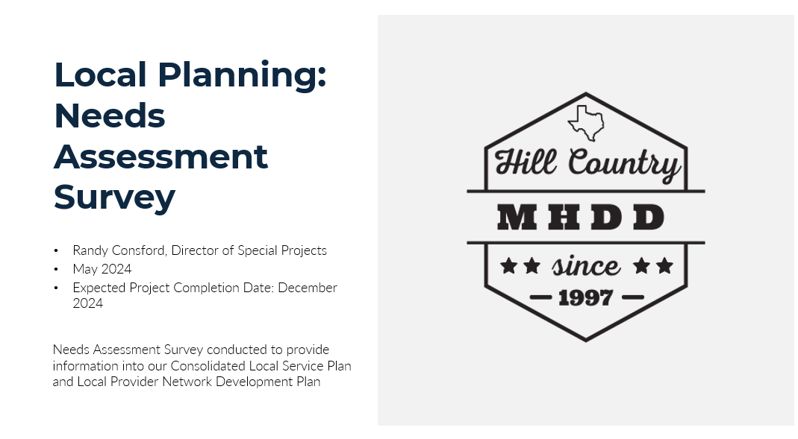
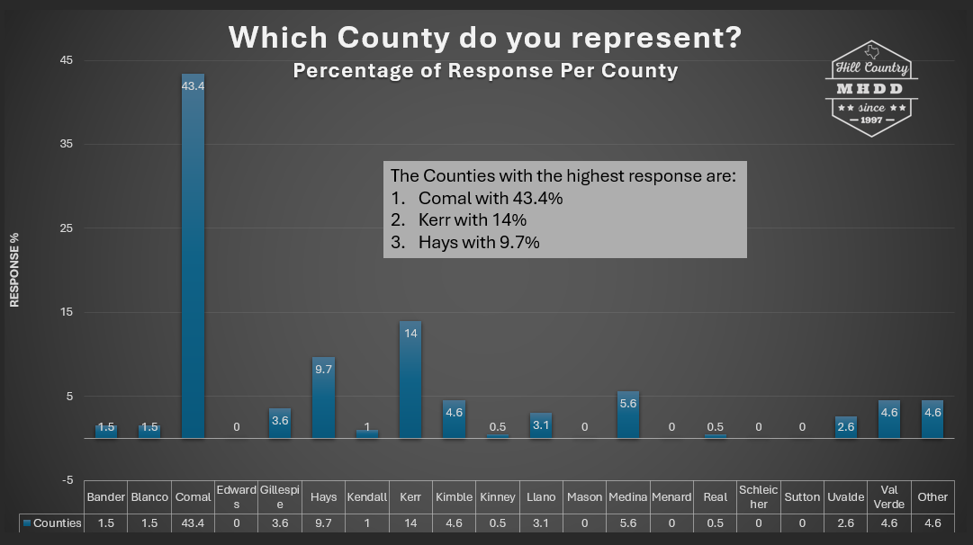

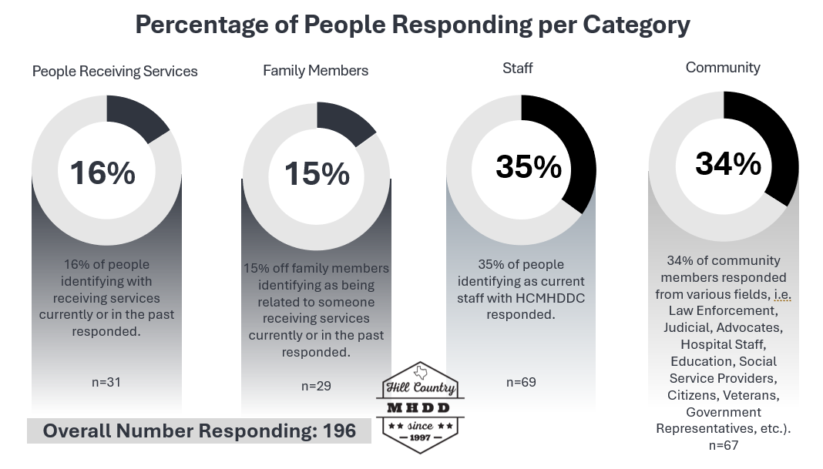
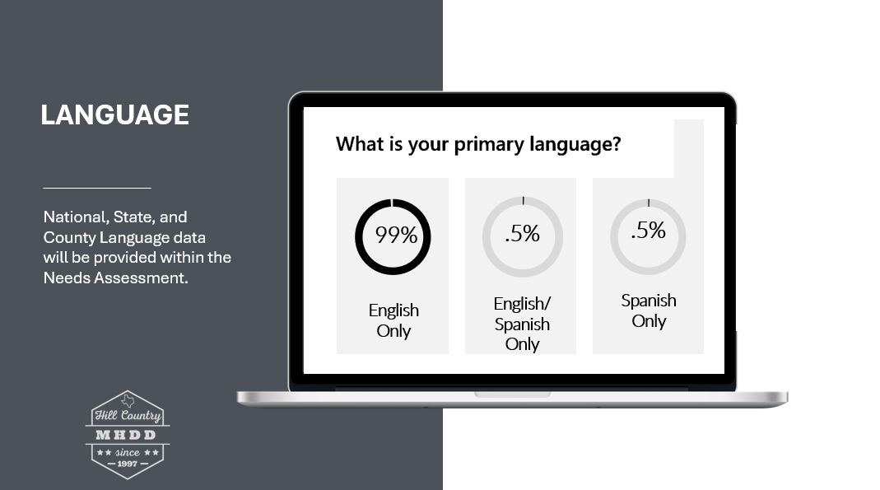

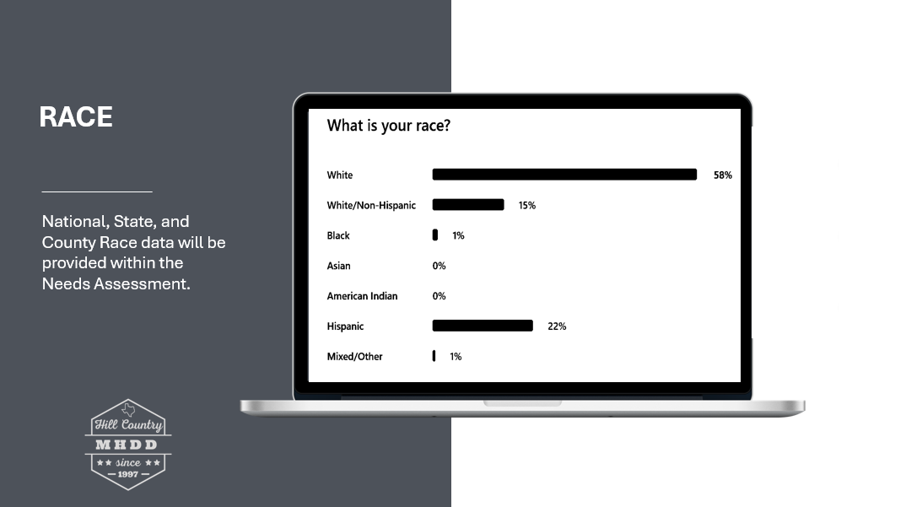

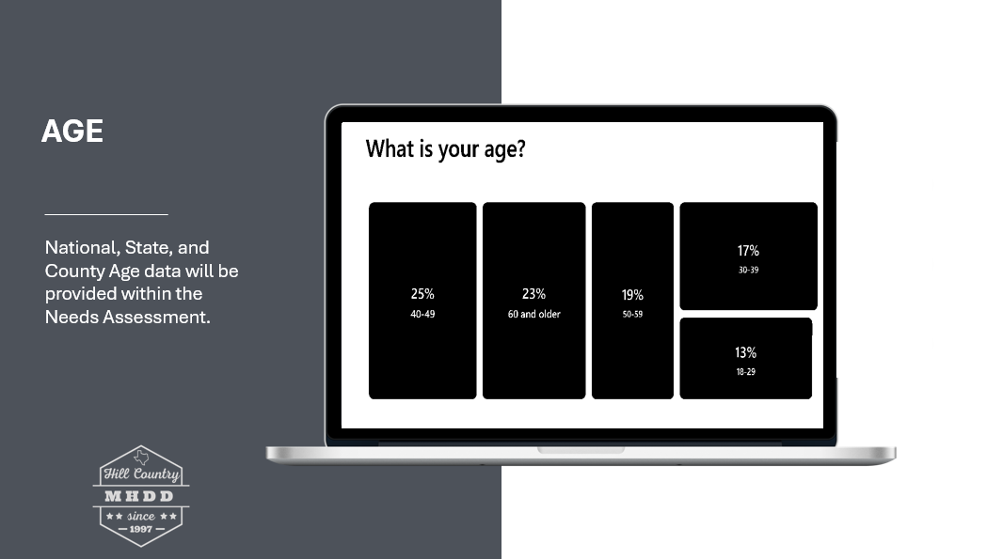

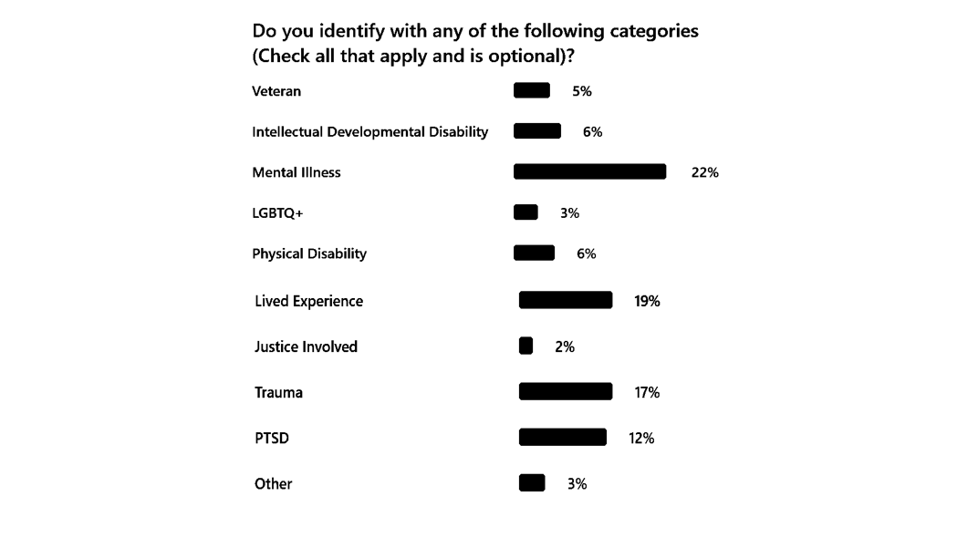

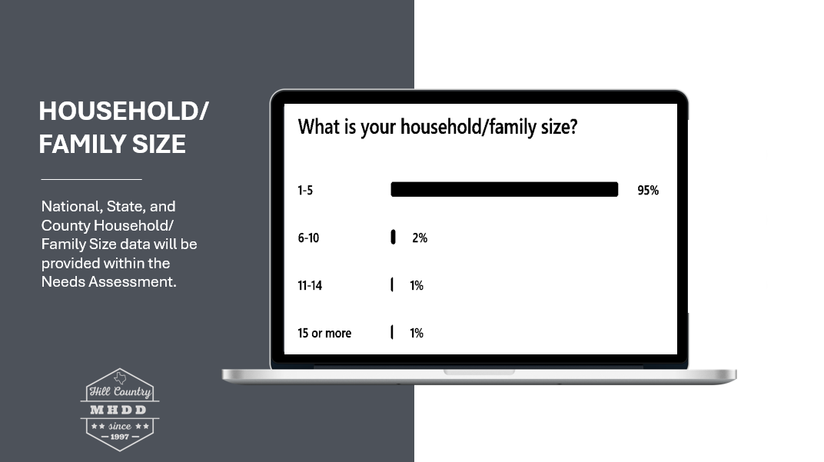

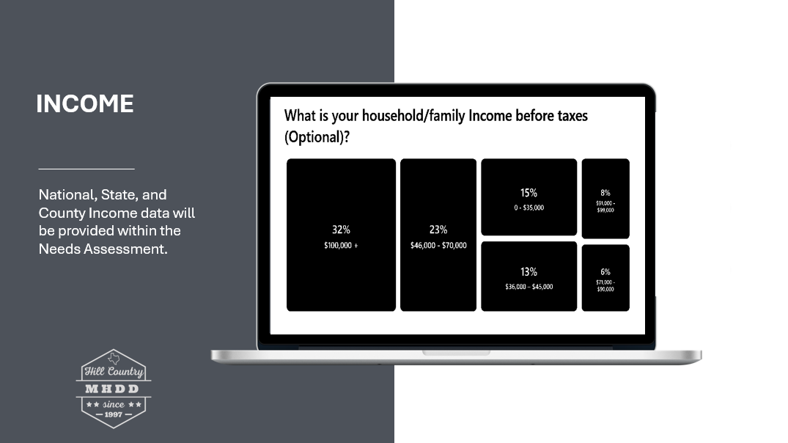
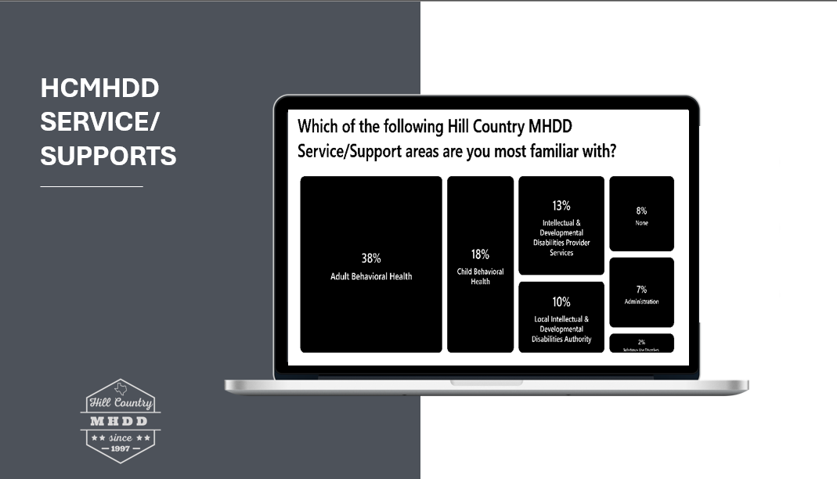

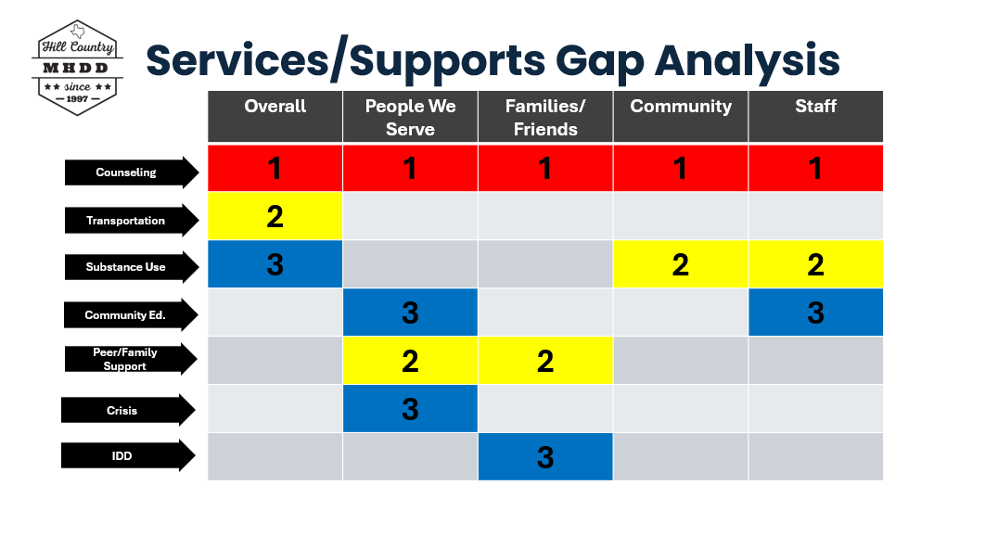

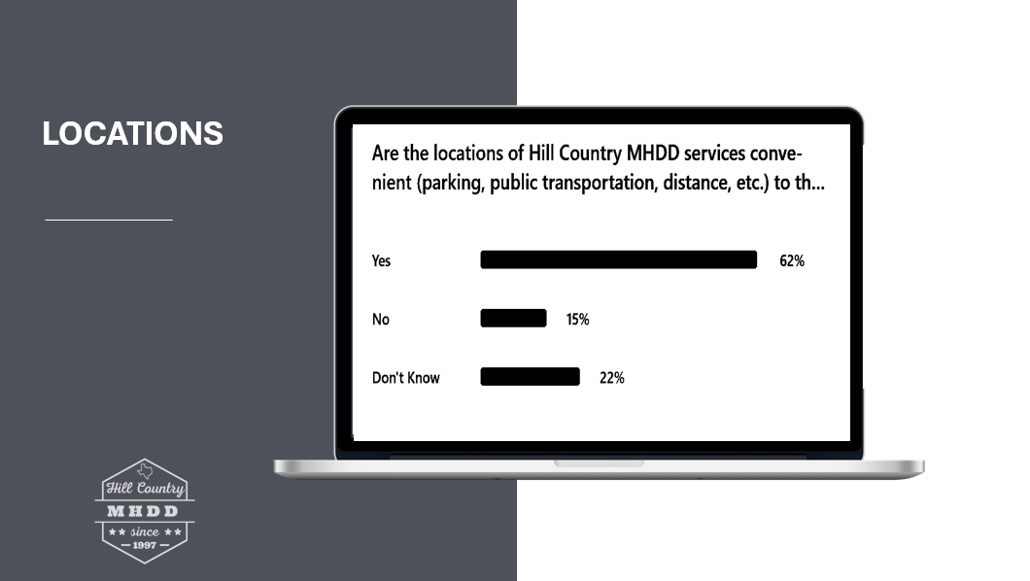

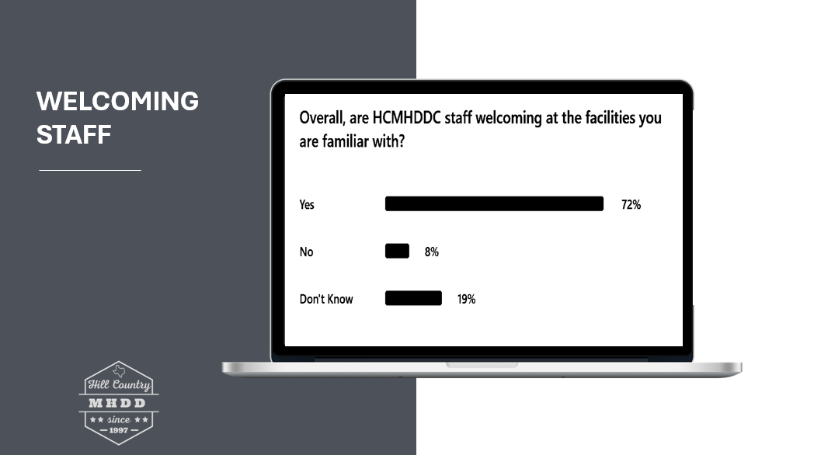

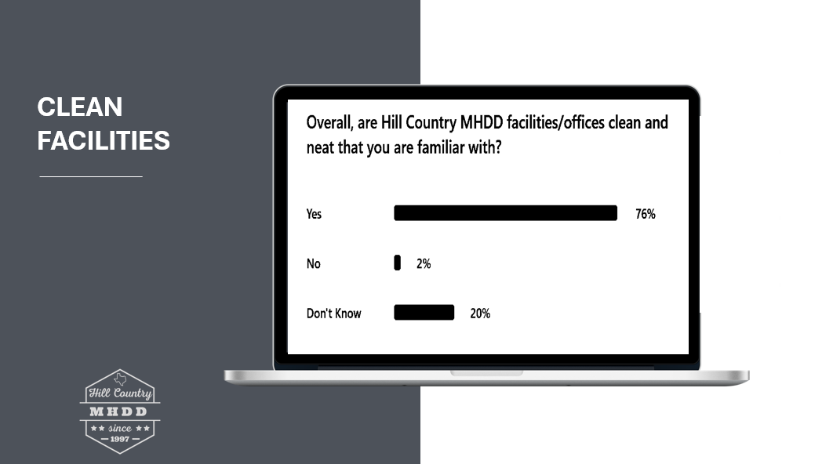

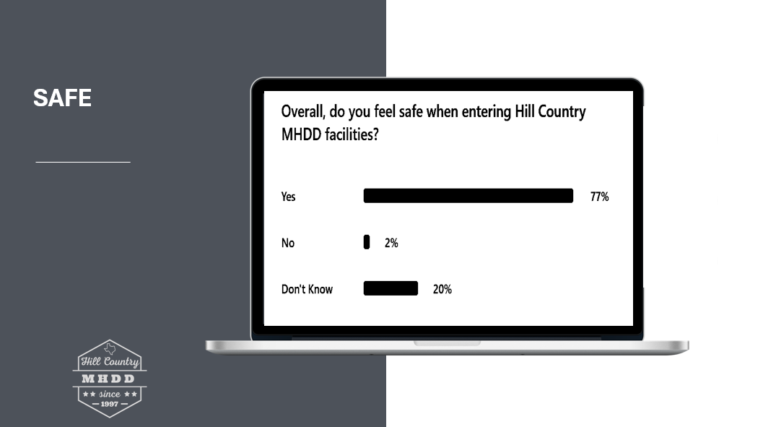

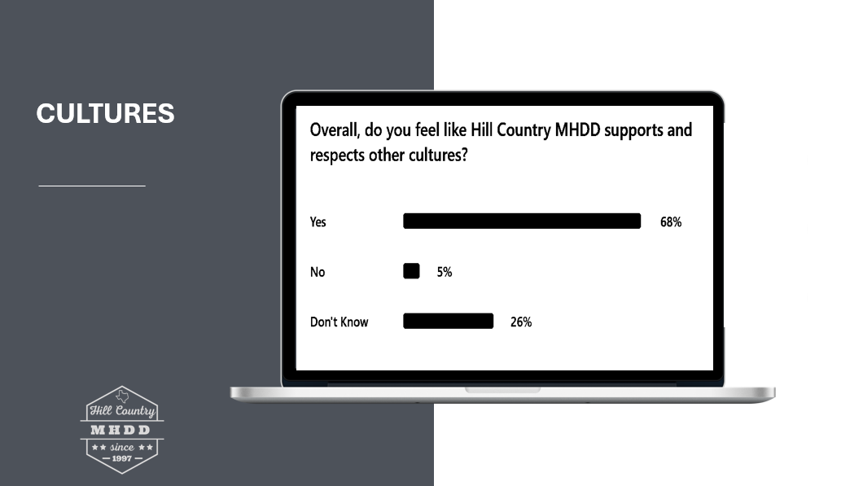

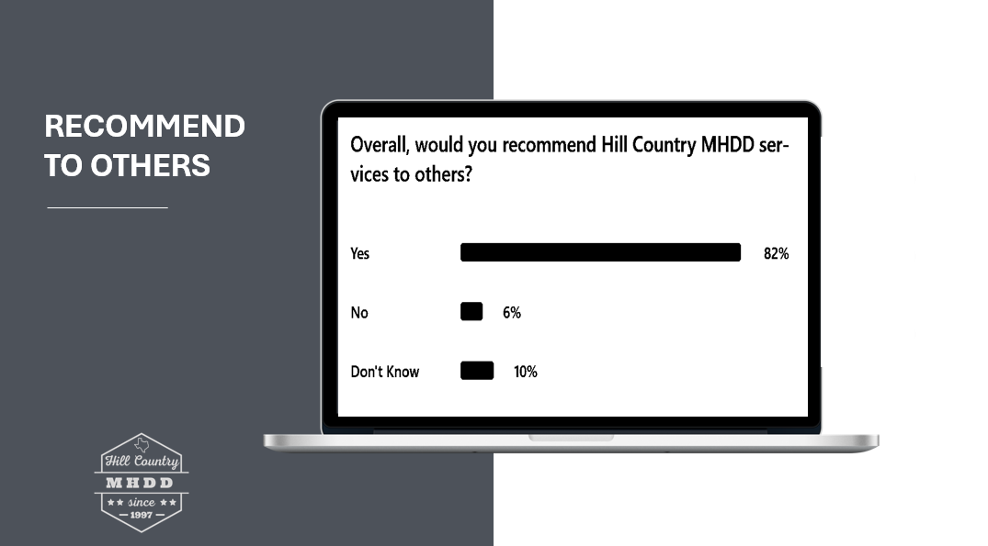

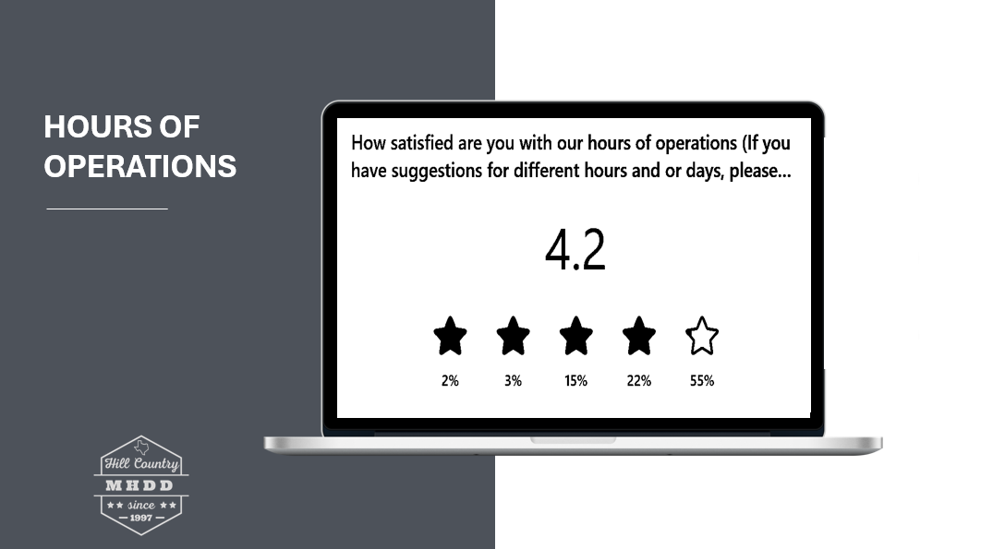

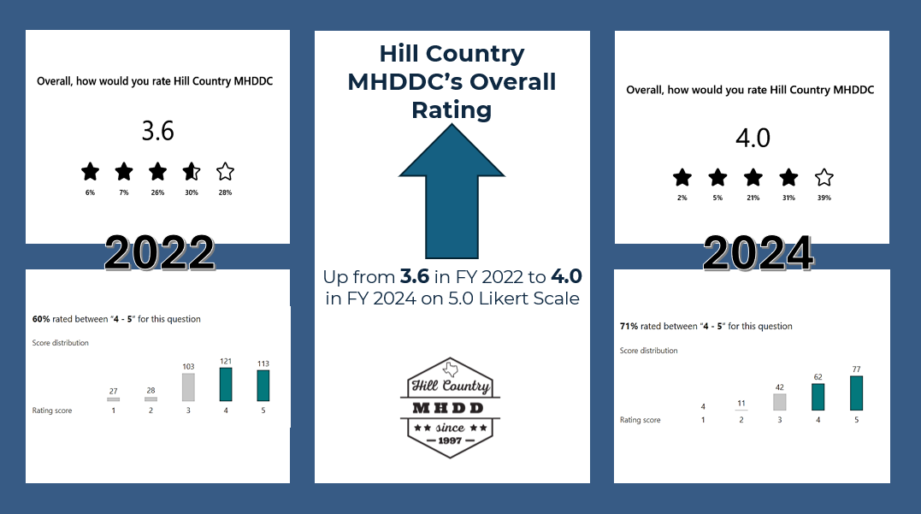

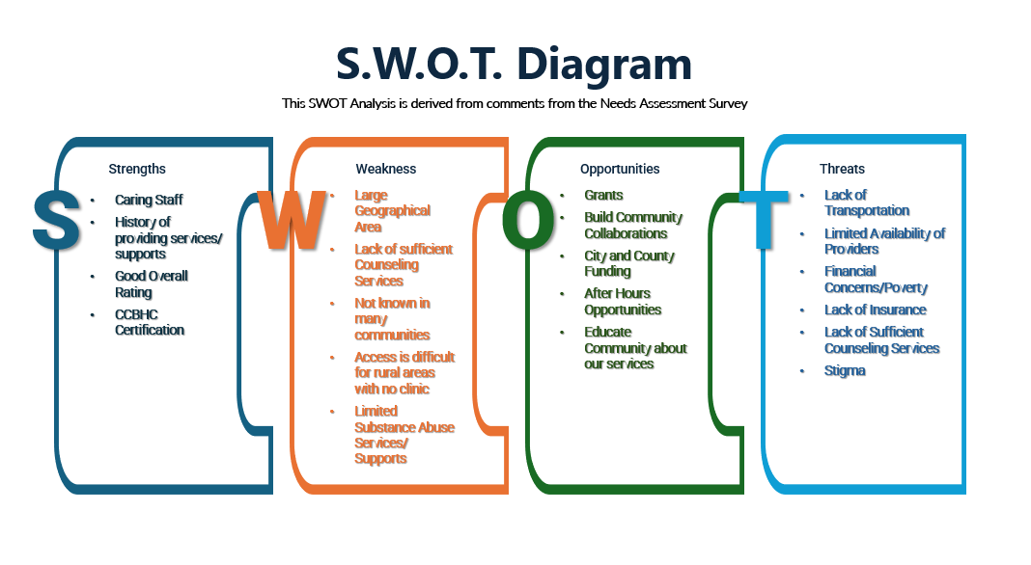

The population estimates for 2023 are subject to revisions as part of an ongoing review processes, with final data expected by the end of 2024.
The counts are of individuals that had an Active Episode at any point during the Fiscal Year 2024 (regardless of service provision). Individuals may be counted only once in each program/county; IDD/LIDDA programs were combined as “IDD”, and individuals are only counted once the IDD column regardless of multiple IDD/LIDDA programs.

